# What is Primary Key?

A primary key in a table that uniquely identifies each row and column or set of columns in the table. The primary key is an attribute or a set of attributes that help to uniquely identify the tuples(records) in the relational table. The primary key provides the means to distinguish one tuple from all the others in the relation. It helps the user to identify the location and also the database system to identify, locate, and refer to one particular tuple in the relations.

* Rule for Primary key
  + Minimal
  + Accessible
  + Non Null
  + Time Invariant
  + Unique
* Syntax For creating primary key

For Creation ALTER TABLE table_name ADD Constraint constraint_name

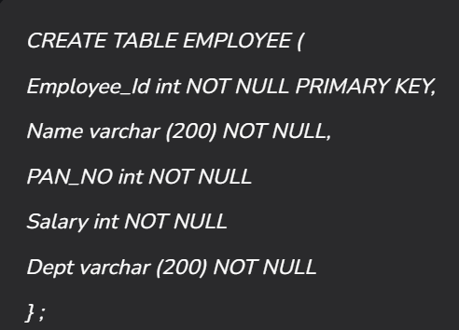

# What is Stored Procedure in SQL?

Stored procedure is a prepared sql code that you can save, so the code can be reused over and over again

So if you have an SQL query that you write over and over again, save it as a stored procedure, and then just call it to execute it.

You can also pass parameters to a stored procedure, so that the stored procedure can act based on the parameter value(s) that is passed.